FINAL INTERNSHIP PROJECT REPORT

Job Skill Extraction and Normalization Using NLP and Machine Learning

- INTRODUCTION
  - Project Background
In today's digital world, recruitment has become highly dependent on online job portals and digital hiring platforms. Every day, companies publish a large number of job vacancies containing information about job roles, required qualifications, experience, technical skills, salary, location, and other requirements.
Although this information is useful, most of it is written in the form of unstructured text. Going through thousands of job descriptions manually to identify the required skills can take a lot of time and effort.
This project focuses on solving this problem using Natural Language Processing (NLP) and Machine Learning. The main purpose is to automatically read job descriptions and identify the skills mentioned in them.
For example, if a job description says that a candidate should have experience with Python, SQL, Pandas, NumPy, and Machine Learning, the system should be able to identify these skills automatically.
The extracted skills can then be cleaned, standardized, categorized, and used for further analysis.

  - Overview of NLP
Natural Language Processing is a field of Artificial Intelligence that helps computers work with human language. Since job descriptions are written in natural language, NLP provides useful techniques for processing this information.
During this project, techniques such as tokenization, stop-word removal, lemmatization, Named Entity Recognition, TF-IDF, semantic similarity, and text classification were explored.
The goal was not simply to find words in the text, but to build a process that could understand the important information present in job descriptions.

  - Job-Skill Extraction
Job-skill extraction means finding the skills required for a particular job from its description.
For example:
Job Description:
"We are looking for a Data Analyst with experience in Python, SQL, Excel, Power BI and data visualization."
The system can identify:
- Python
- SQL
- Excel
- Power BI
- Data Visualization
This information can be used to understand what skills employers are looking for in different job roles.

- PROBLEM STATEMENT & OBJECTIVES
The report index identifies this section as covering the problem statement, business objective, technical objective, and expected outcome.
  - Problem Statement
Job descriptions contain valuable information about the skills and qualifications required by companies, but this information is usually available as unstructured text.
Manually extracting skills from a large number of job descriptions is difficult, time-consuming, and prone to inconsistency. Another challenge is that the same skill can be written in different ways. For example, "ML" and "Machine Learning" refer to the same skill.
Therefore, there is a need for a system that can automatically extract skills from job descriptions and convert different versions of the same skill into a common format.

  - Business Objective
The business objective of this project is to make recruitment-related analysis faster and easier.
The system can help organizations:
- Identify commonly requested skills.
- Understand skill requirements for different job roles.
- Reduce manual analysis.
- Analyze large numbers of job postings.
- Understand current skill demand.
- Support recruitment-related decision-making.

  - Technical Objective
From a technical point of view, the project aims to:
- Understand and clean the job dataset.
- Perform exploratory data analysis.
- Preprocess job-description text.
- Create a skill taxonomy.
- Extract skills using rule-based techniques.
- Apply statistical NLP techniques.
- Explore NER-based extraction.
- Apply machine-learning techniques.
- Explore transformer-based models.
- Normalize and categorize extracted skills.
- Evaluate the results.
- Present the results through visualizations.

  - Expected Outcome
At the end of the project, the expected outcome is a system that can take job descriptions as input and produce a structured list of skills.
The extracted information can then be used for analysis, dashboards, recruitment applications, and future job-matching systems

- PROJECT SCOPE & USE CASE
The project focuses mainly on extracting useful skill-related information from job descriptions.

  - Recruitment Use Case
Recruiters often need to compare the requirements of different jobs. Instead of manually reading every job description, an automated NLP system can extract the important skills.
For example, if a company has hundreds of Data Analyst job postings, the system can identify how frequently skills such as SQL, Python, Excel, Power BI, and Tableau are mentioned.
This makes it easier to understand the skill requirements of the job market.

  - Practical Applications
The project can be useful in several areas:
- Recruitment analytics
- Job-market analysis
- Resume screening
- Candidate-job matching
- Skill-gap analysis
- Career guidance
- Training recommendations
- Workforce planning
The current project mainly focuses on job-skill extraction and analysis, while some of these applications can be considered future extensions.

- TECHNOLOGY & TOOLS USED
The project uses a combination of Python libraries and analytical tools. The index specifically lists Python, Pandas, NumPy, NLTK, spacy, Scikit-learn, Transformers, Power BI/Tableau, and Streamlit / FastAPI.

  - Python
Python was used as the main programming language because it provides many libraries for data analysis, NLP, and machine learning.
  - Pandas
Pandas was used mainly for working with the dataset.
It helped with:
- Reading CSV files
- Checking data
- Cleaning data
- Handling missing values
- Removing duplicates
- Performing analysis

  - NumPy
NumPy was used for numerical operations and handling numerical data during analysis and machine-learning tasks.
  - NLTK
NLTK was used for basic NLP operations such as tokenization and stop-word handling.
  - Spacy
spacy was particularly useful for processing job-description text and working with Named Entity Recognition.
  - Scikit-learn
Scikit-learn was used for machine-learning and text-processing tasks such as:
- TF-IDF
- Train-test splitting
- Classification
- Model evaluation

  - Transformers
Transformer-based models such as BERT, Distilbert, and roberta were considered for understanding text in a more contextual way.
  - Power BI
Power BI can be used to present the extracted skill information in the form of interactive dashboards.
  - Streamlit/FastAPI
Streamlit can be used to create a simple user interface where a user enters a job description and receives extracted skills.
FastAPI can be used when the extraction system needs to be exposed as an API.

- SYSTEM ARCHITECTURE & METHODOLOGY
The report index asks for the complete workflow and architecture of the project.

The project follows a step-by-step approach, starting with the job dataset and ending with structured skill information.

  - Overall Workflow
Dataset → Data Cleaning → EDA → NLP Preprocessing → Skill Taxonomy → Skill Extraction → Normalization → Categorization → Evaluation → Dashboard/Application

  - Methodology
Step 1: Dataset Collection
Collect job-posting information containing job titles, companies, descriptions, locations, experience, education, salary, job type, and extracted skills.
Step 2: Data Understanding
Analyze:
- Number of records
- Number of columns
- Data types
- Missing values
- Duplicate records
Step 3: Data Cleaning
Clean inconsistent and missing data.
Step 4: NLP Preprocessing
Process job descriptions using NLP techniques.
Step 5: Skill Taxonomy
Create a dictionary containing standard skills and their aliases.
Step 6: Skill Extraction
Extract skills using different approaches.
Step 7: Skill Normalization
Convert different variations of a skill into one canonical name.
Step 8: Categorization
Assign skills to categories such as:
- Programming Languages
- Databases
- Data Science
- Machine Learning
- Cloud
- Web Development
- Visualization
Step 9: Evaluation
Evaluate extraction and classification performance.
Step 10: Visualization
Create dashboards showing skill demand and other insights.

- DATASET COLLECTION & UNDERSTANDING
The index specifies that this section should cover dataset source, dataset fields, number of records, and data inspection.
  - Dataset
The project uses a job-posting dataset containing both structured information and unstructured job-description text.
Column | Description
Job ID | Unique ID of the Job
Job Title | Title of the position
Company | Company Offering the job
Location | Location of the job
Job description | Detailed description of the position
Experience | Required experience
Education | Required education
Salary | Salary information
Job type | Type of employment
Extracted skills | Skills associated with the job

  - Data Inspection
For the data inspection I have use the such code lines:

- df.head()
- df.shape
- df.info()
- df.isnull().sum()
- df.duplicated().sum()

- EXPLORATORY DATA ANALYSIS
The EDA section should cover job titles, locations, description length, missing values, duplicates, and visualizations.
  - Job Title Analysis
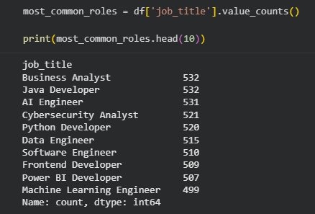
  - Location Analysis
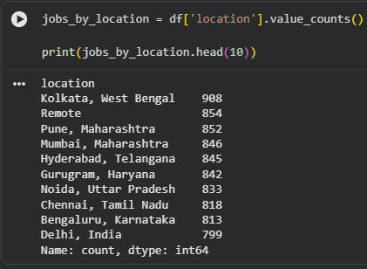
  - Job Description Length
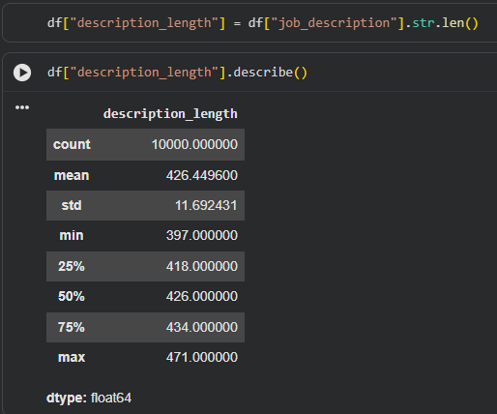
  - Missing Values
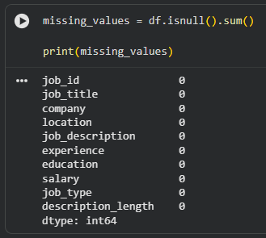
  - Duplicate Records
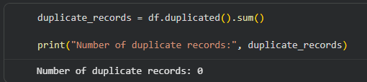
  - Visualization
Possible visualizations include:
- Top job titles
- Jobs by location
- Description-length distribution
- Missing-value chart
- Job-type distribution

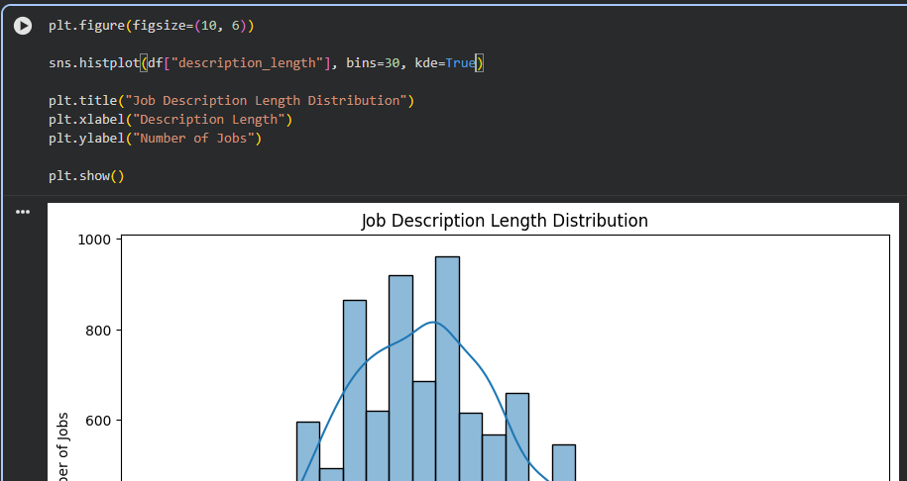
- DATA CLEANING & NLP PREPROCESSING
The index requires data cleaning, tokenization, stopwords, stemming, lemmatization, and sentence segmentation.
  - Text Cleaning
Job descriptions may contain:
- HTML tags
- Special characters
- Extra spaces
- Unnecessary punctuation
- Inconsistent capitalization

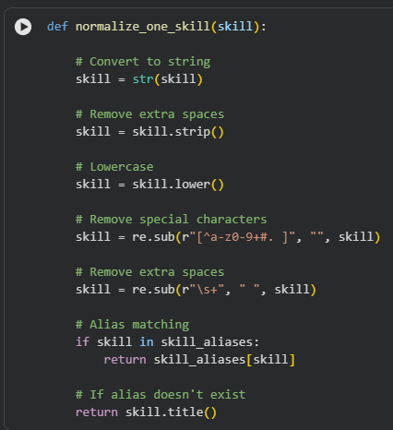
  - Tokenization
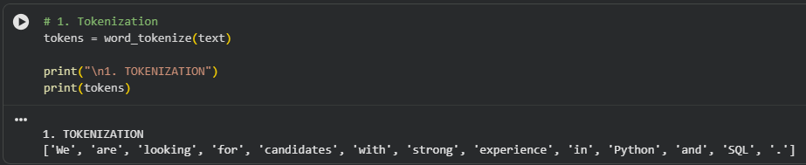
  - Stopword Removal
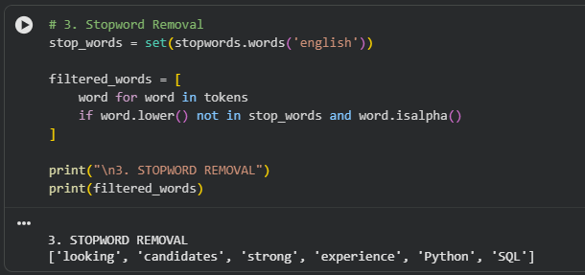
  - Stemming
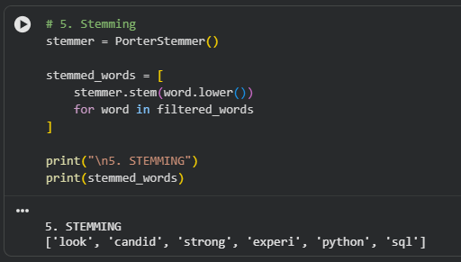
  - Lemmatization
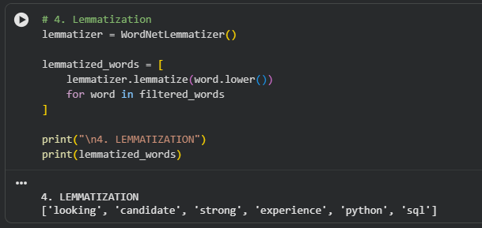
  - Sentence Segmentation
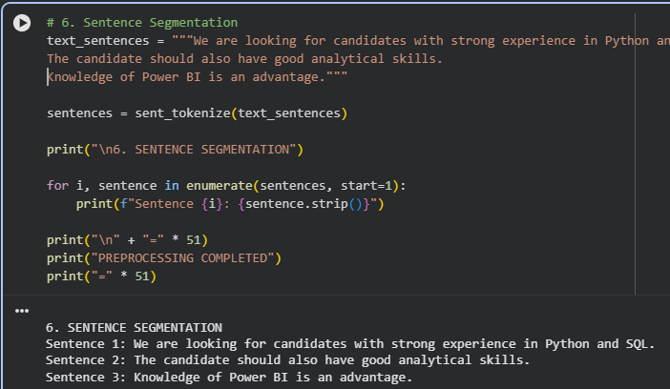
- SKILL TAXONOMY DEVELOPMENT
The index requires a skill dictionary, categories, aliases/synonyms, and canonical skills.
  - Skill Taxonomy
A skill taxonomy is a structured representation of skills and their categories.
  - Aliases
Different terms can represent the same skill.
  - Importance
Skill taxonomy makes extracted information consistent and easier to analyze.
- RULE-BASED SKILL EXTRACTION
The index specifies dictionary matching, regex, and phrase matching for this section
  - Dictionary Matching
A predefined list of skills can be searched in the job description.
  - Regex Matching
Regular expressions can identify specific patterns.
  - Phrase Matching
Multi-word skills require phrase matching.
Examples:
- Machine Learning
- Deep Learning
- Data Science
- Natural Language Processing
Rule-based extraction is simple, fast, and interpretable, but it depends heavily on the quality of the skill dictionary.

- STATISTICAL & SEMANTIC NLP TECHNIQUES
The index includes TF-IDF, N-Grams, Word Embeddings, and Semantic Similarity.
  - TF-IDF
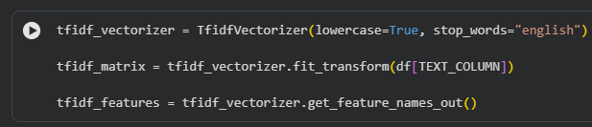
  - N-Grams
N-grams are sequences of words.
- Unigram:
machine
- Bigram:
machine learning
- Trigram:
natural language processing

  - Word Embeddings
Word embeddings represent words as numerical vectors.
They allow NLP systems to capture relationships between words.

  - Semantic Similarity
Semantic similarity determines how closely related two pieces of text are.
This is useful for identifying similar skill names even when the exact words are different.

- NAMED ENTITY RECOGNITION
The index requires standard NER, custom entities, and a custom NER approach.
  - Standard NER
Spacy provide pre-trained NER models.
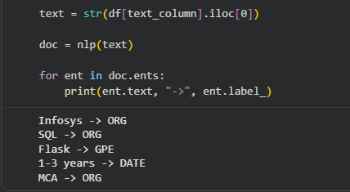
  - Custom NER
A custom NER model can be trained to recognize entities specific to job descriptions.

- Python → SKILL
- SQL → SKILL
- AWS → SKILL
- Machine Learning → SKILL

  - Advantages
Custom NER can recognize domain-specific entities that general-purpose NER models may not identify correctly.
- MACHINE LEARNING MODEL
Custom NER can recognize domain-specific entities that general-purpose NER models may not identify correctly.
  - Training Data
The dataset should be divided into training and testing data.
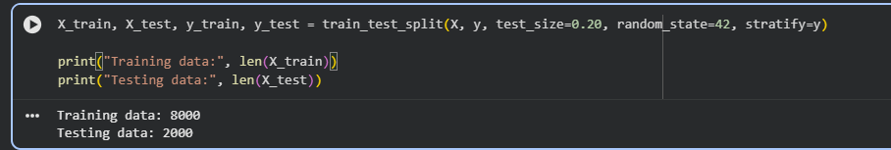
  - Feature Engineering
Text can be converted into numerical features using TF-IDF.
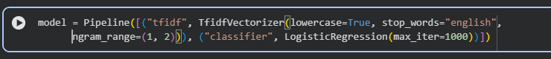
  - ML Model
A classification algorithm can then be trained.
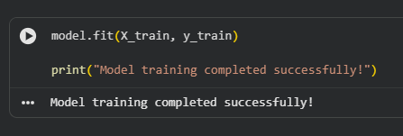
  - Prediction
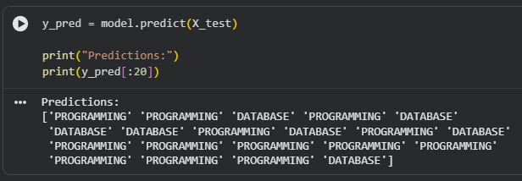
- TRANSFORMER-BASED MODEL
The index specifically mentions BERT, Distilbert, Roberta, model approach, and extraction process.
  - Transformers
Transformer models use attention mechanisms to understand contextual relationships within text.
Popular transformer models include:
- Bert
- Distilbert
- Roberta

  - Bert
BERT is a transformer-based language model designed to understand words in their surrounding context.
  - DistilBert
Distilbert is a smaller version of BERT designed to provide faster processing while retaining much of BERT's language-understanding capability.
  - Roberta
Roberta is an optimized transformer-based language model derived from the BERT architecture.
  - Skill Extraction Process
A transformer-based extraction workflow can be:
Job Description → Tokenization → Transformer Model → Contextual Representation → Entity/Skill Identification → Normalization

- MODEL EVALUATION & COMPARISON
The index requires Precision, Recall, F1-score, Accuracy, Confusion Matrix, and model comparison.
  - Accuracy
Accuracy represents the proportion of correct predictions.
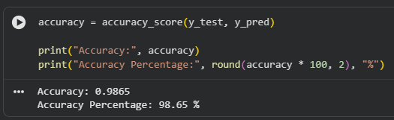
  - Precision
Precision measures how many predicted positive results were actually positive.
  - Recall
Recall measures how many actual positive cases were successfully identified.

  - F1-Score
F1-score combines precision and recall.
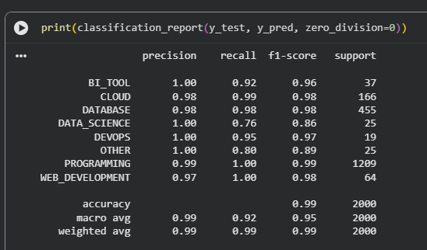
- ERROR ANALYSIS
The index identifies false positives, false negatives, partial entities, synonyms, and spelling issues.
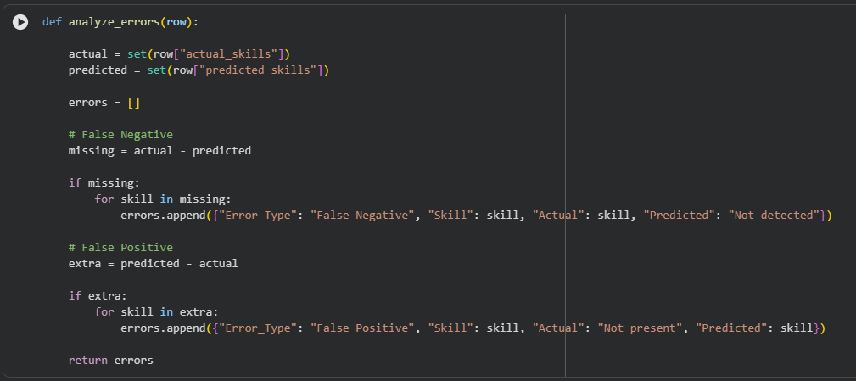
  - Partial Entity
The system may identify only part of a multi-word skill.
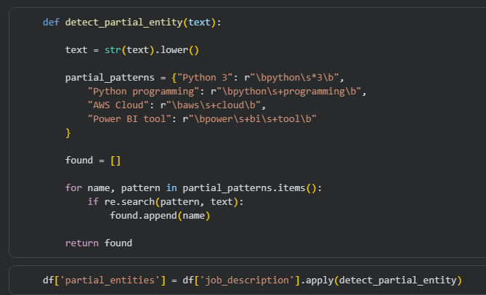
  - Synonyms
Different terms can refer to the same technology.
  - Spelling Issues
Typos and spelling variations can reduce extraction accuracy.
- SKILL NORMALIZATION & CATEGORIZATION
The index specifies alias matching, canonical skills, and category mapping.
  - Skill Normalization
Normalization converts different representations into one standard form.
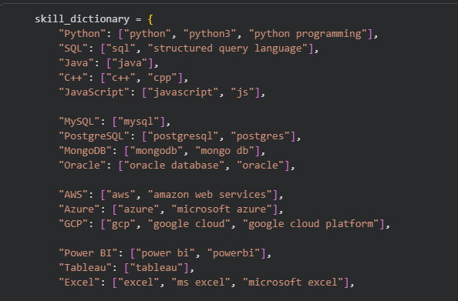
  - Canonical Skills
A canonical skill is the standard name used for analysis.
For example:
- ML → Machine Learning
- JS → JavaScript
- Py → Python

  - Category Mapping
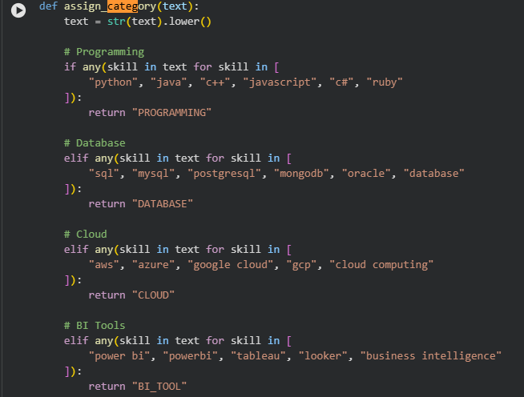
- DASHBOARD & DATA VISUALIZATION
The index specifies KPIs, top skills, skill demand by role, category distribution, and trends.
  - Dashboard Objectives
The dashboard provides an interactive overview of the extracted skill information.
  - Key Performance Indicators
Possible KPIs:
- Total Jobs
- Total Skills
- Unique Skills
- Most Demanded Skill
- Number of Job Roles
- Number of Companies

  - Top Skills
A bar chart can show the most frequently requested skills.
  - Skill Demand by Role
A visualization can compare skills across different job roles.
  - Category Distribution
A pie/donut or bar chart can display the distribution of skill categories.
  - Trends
If the dataset contains time information, trends can be analyzed over time.
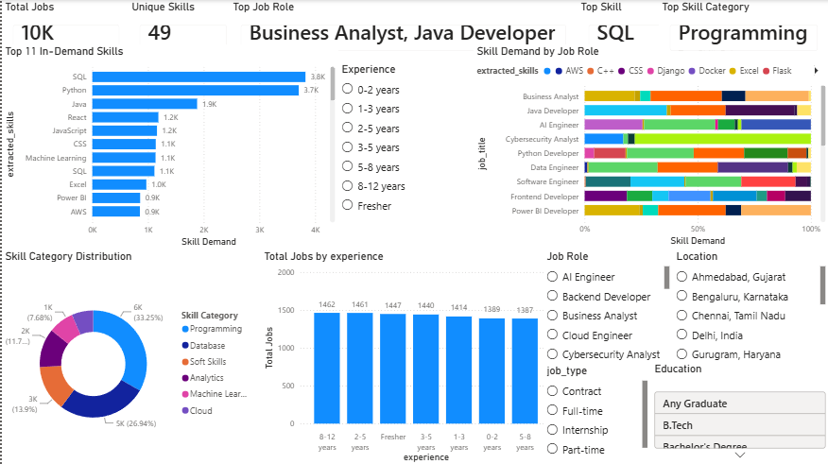

- APPLICATION / API DEVELOPMENT
The index requires application interface, input/output, extraction pipeline, and architecture.
  - Application Interface
A simple application can allow users to enter a job description.
https://skillapplication-m9xdsqjwob6rlvkkfuc2zx.streamlit.app/
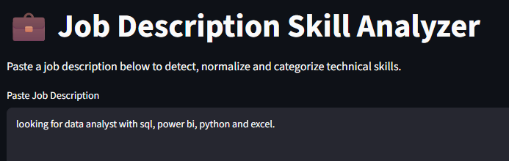
  - Expected Output
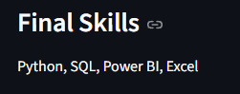
  - Extraction Pipeline
Streamlit can be used to create an interactive interface.
  - Streamlit
The index requires test cases, sample outputs, validation, and final results.
- TESTING & RESULTS
The index requires test cases, sample outputs, validation, and final results.
  - Testing
The system should be tested using different job descriptions.
Test Case 1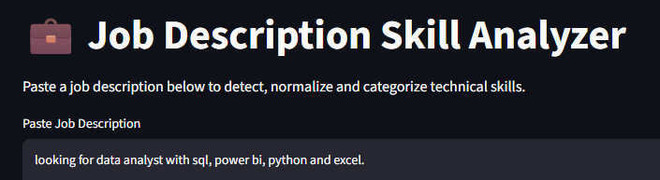


Test Case 2
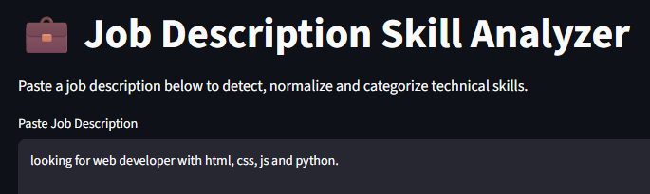
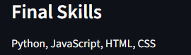
  - Validation
Validation should compare the extracted skills with manually verified results.
  - Final Results
The final results section should contain your actual measured model performance, number of extracted skills, normalization results, and dashboard outputs.
- CHALLENGES & LIMITATIONS
The index requires problems faced, model limitations, and dataset limitations.
  - Challenges
Some challenges include:
- Unstructured job descriptions
- Different skill names
- Abbreviations
- Spelling variations
- Multi-word skills
- Missing information
- Duplicate records
- Ambiguous terms

  - Model Limitations
Rule-based systems depend on predefined dictionaries.
Traditional ML models may have difficulty understanding context.
Transformer models can require more computational resources and appropriate training data.

  - Dataset Limitations
Potential limitations include:
- Limited dataset size
- Incomplete job descriptions
- Inconsistent formatting
- Missing values
- Limited representation of some job roles

- CONCLUSION
The project demonstrates how Natural Language Processing and Machine Learning can be used to automatically identify skills from job descriptions.
The developed workflow covers data understanding, exploratory analysis, text preprocessing, skill taxonomy development, rule-based extraction, statistical NLP, machine learning, transformer-based techniques, skill normalization, categorization, evaluation, and visualization.
The project helps transform unstructured job-description text into structured skill information that can be used for recruitment analytics and job-market analysis.

- FUTURE SCOPE
The index identifies resume-job matching, candidate ranking, skill-gap analysis, and recommendation systems as future applications.
  - Resume-Job Matching
The system can compare candidate resumes with job descriptions and calculate compatibility.
  - Candidate Ranking
Candidates can be ranked according to their skill match with a particular job.
  - Skill-Gap Analysis
The system can identify skills required for a job that are missing from a candidate's profile.
  - Recommendation System
The system can recommend:
- Suitable jobs
- Relevant courses
- Skills to learn
- Career paths

  - Advanced NLP
Future versions can use larger transformer models and domain-specific training to improve extraction accuracy.
- INTERNSHIP LEARNING OUTCOMES
The index requires technical, analytical, NLP, ML, and project-development skills learned.
During the internship project, several technical and analytical skills were developed.
  - Technical Skills
- Python programming
- Pandas
- NumPy
- Data preprocessing
- Data visualization
- Machine learning
  - NLP Skills
  - Tokenization
  - Stopword removal
  - Lemmatization
  - NER
  - TF-IDF
  - N-grams
  - Semantic similarity
  - Skill extraction
  - Machine Learning Skills
  - Dataset preparation
  - Feature engineering
  - Model training
  - Model testing
  - Model evaluation
  - Classification
  - Analytical Skills
- Analyze datasets
- Identify patterns
- Interpret visualizations
- Compare models
- Identify errors
  - Project Development Skills
The project provided practical experience in building an end-to-end NLP pipeline from raw data to analytical output.
- REFERENCES
The final report should include the actual resources used during the project. The provided index asks for dataset sources, documentation, research papers and libraries/resources.

Suggested reference categories:

- Python Documentation
- Pandas Documentation
- NumPy Documentation
- NLTK Documentation
- spacy Documentation
- Scikit-learn Documentation
- Hugging Face Transformers Documentation
- Power BI Documentation
- Tableau Documentation, if used
- Streamlit Documentation, if used
- FastAPI Documentation, if used
- Dataset source used for the project
- Research papers related to NLP and skill extraction

- APPENDIX
  - Dataset Loading
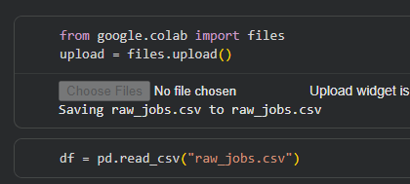
  - Checking Missing Values
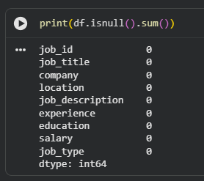
  - Checking Duplicates
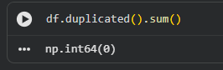
  - Text Cleaning

  - Skill Extraction
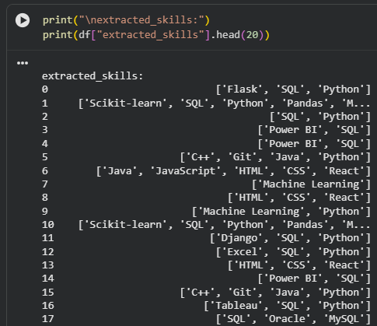
  - TF-IDF
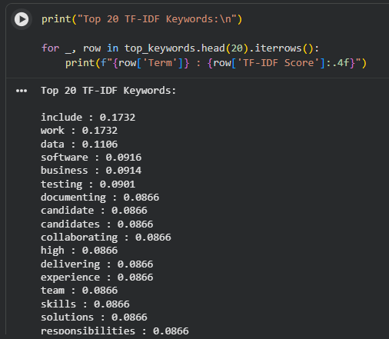
  - spacy NER
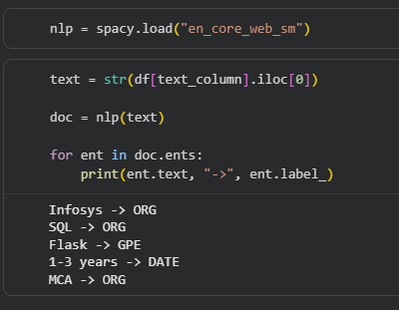
  - Skill Normalization

